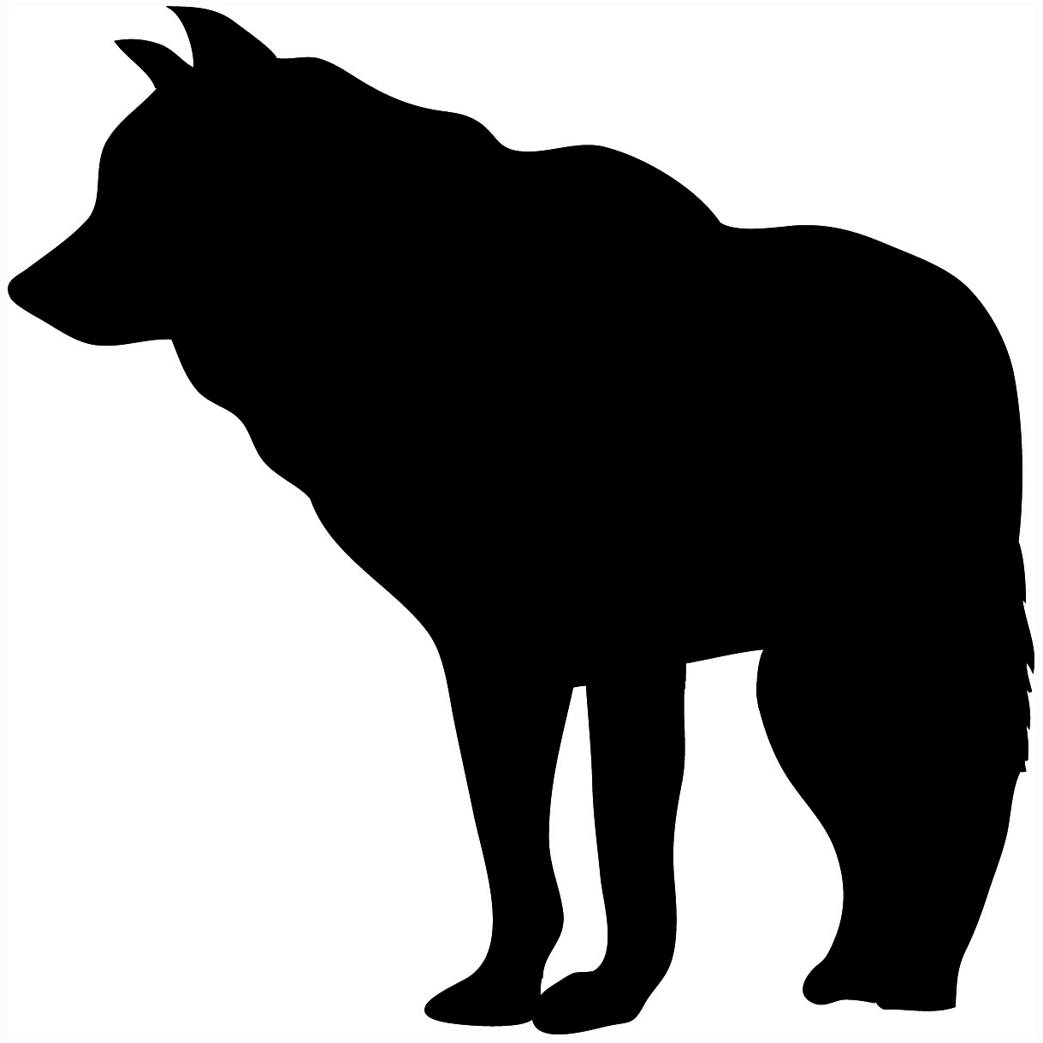  
 [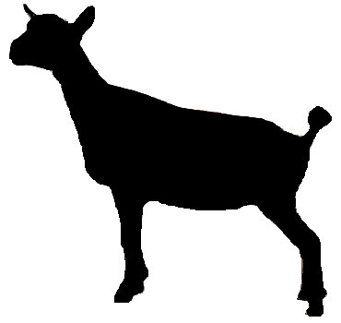](http://www.google.co.uk/url?sa=i&rct=j&q=&esrc=s&frm=1&source=images&cd=&cad=rja&docid=532gm4JWHhbapM&tbnid=8eXljXyDrlTHvM:&ved=0CAUQjRw&url=http://pemberleyacres.com/kids.htm&ei=pyRHUveMHZHItAbXxIDoDg&psig=AFQjCNHjPumBhiex7-MlXvt57_i3_6FHMQ&ust=1380480424785666)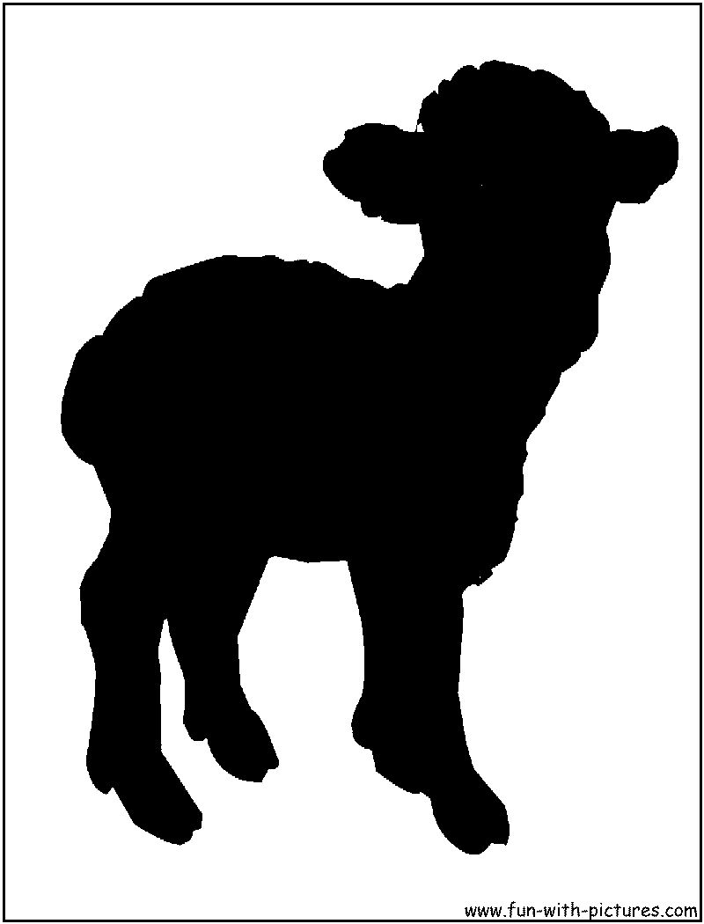[](http://www.google.co.uk/url?sa=i&rct=j&q=&esrc=s&frm=1&source=images&cd=&cad=rja&docid=jiw-sC6QERGOHM&tbnid=coIsGtHwEcGfqM:&ved=0CAUQjRw&url=http://www.clker.com/clipart-leopard-silhouette.html&ei=7CRHUumjGYLsswbgvIH4Bg&psig=AFQjCNFnQfAAVE37k6MXNfjQaZCNP2XVFg&ust=1380480584615034)[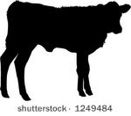](http://www.google.co.uk/url?sa=i&rct=j&q=&esrc=s&frm=1&source=images&cd=&cad=rja&docid=f19_MdRirCh5JM&tbnid=747ASxt_1OvhUM:&ved=0CAUQjRw&url=http://vector.me/browse/373762/chewing_cow&ei=USZHUszbDoXnswb264CwDA&psig=AFQjCNH_rsbm85LaUmnGvv9we9-IWzx9nA&ust=1380480948766268)[](http://www.google.co.uk/url?sa=i&rct=j&q=&esrc=s&frm=1&source=images&cd=&cad=rja&docid=AxCPE3jOgaB0bM&tbnid=VqQ4Qg77wxSiCM:&ved=0CAUQjRw&url=http://www.vinylsilhouettes.com/childrensilhouettes.html&ei=nCdHUqz0E8fAtAaS7oHoBA&psig=AFQjCNEUqXXFb2HEBY9U5bzB3DPl5drQvA&ust=1380481293357013)[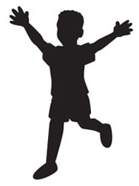](http://www.google.co.uk/url?sa=i&rct=j&q=&esrc=s&frm=1&source=images&cd=&cad=rja&docid=KpGKvqjYlkufvM&tbnid=xLmIAz7_ngLtRM:&ved=0CAUQjRw&url=http://www.oininteractive.com/graphic-design/logo-re-design-a-short-case-study/&ei=1CdHUrjNCcGStQbbnICgDQ&psig=AFQjCNEUqXXFb2HEBY9U5bzB3DPl5drQvA&ust=1380481293357013)[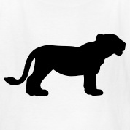](http://www.google.co.uk/url?sa=i&rct=j&q=&esrc=s&frm=1&source=images&cd=&cad=rja&docid=Y3-VD_Ys9yz2cM&tbnid=Cb9xn_k-kccR2M:&ved=0CAUQjRw&url=http://www.spreadshirt.com/lion+silhouette+t-shirts&ei=oSZHUpjZAoqPtQaT4YCYBg&psig=AFQjCNGJ8_sLidKQkJg-wsYih2MwssnAzg&ust=1380481049312848)[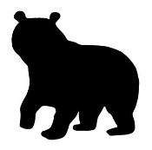](http://www.google.co.uk/url?sa=i&rct=j&q=&esrc=s&frm=1&source=images&cd=&cad=rja&docid=AH1eWIaZEtnLZM&tbnid=Cf1HSFyB0x3AKM:&ved=0CAUQjRw&url=http://stickthisgraphics.com/Wild-Animal-Decals-Stickers_c147.htm?page=all&ei=fylHUsjfG4mPswb57YDwBg&psig=AFQjCNEa4gZaPTQ4uZeJYcDw1L-8vdXpUw&ust=1380481669821937)[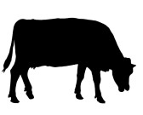](http://www.google.co.uk/url?sa=i&rct=j&q=&esrc=s&frm=1&source=images&cd=&cad=rja&docid=ZCJXrIdjUzTm2M&tbnid=hYvqXoAgKDLGxM:&ved=0CAUQjRw&url=http://www.123rf.com/clipart-vector/graze.html&ei=RihHUvXDBofBtAbFxYGQBA&psig=AFQjCNGsM3-2CdIlEhobY3CGXLr1GVyvpw&ust=1380481463652615)[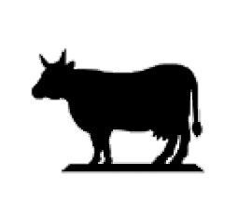](http://www.google.co.uk/url?sa=i&rct=j&q=&esrc=s&frm=1&source=images&cd=&cad=rja&docid=9Qwet25HN9izJM&tbnid=Glk1muUImhhR0M:&ved=0CAUQjRw&url=http://www.metal-silhouette-art.co.uk/index.php?main_page=product_info&cPath=35&products_id=267&ei=GCtHUr7DLobTtAbwsICADQ&psig=AFQjCNHmstovo0uRJioIvR5Lfg1OGRXoSg&ust=1380482144344824)[](http://www.google.co.uk/url?sa=i&rct=j&q=&esrc=s&frm=1&source=images&cd=&cad=rja&docid=TNFFDuAO-IYQVM&tbnid=549CI28Ar69kAM:&ved=0CAUQjRw&url=http://www.freepik.com/free-vector/baby-silhouette_516974.htm&ei=gCtHUs_nLcGstAafvYGYDg&psig=AFQjCNEpyd2c32peZTWqNpfawWi3kpdBLg&ust=1380482272280209) [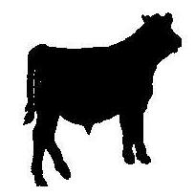](http://www.google.co.uk/url?sa=i&rct=j&q=&esrc=s&frm=1&source=images&cd=&cad=rja&docid=re7M6DnivSHkxM&tbnid=zArGpLWb6fdXwM:&ved=0CAUQjRw&url=http://www.djclassics.net/silhouettes.htm&ei=By5HUqbTPMGYtQbuioDIBw&psig=AFQjCNH9VrXaZo57oy4SXuh7GwPhZBGPIg&ust=1380482875697437)

[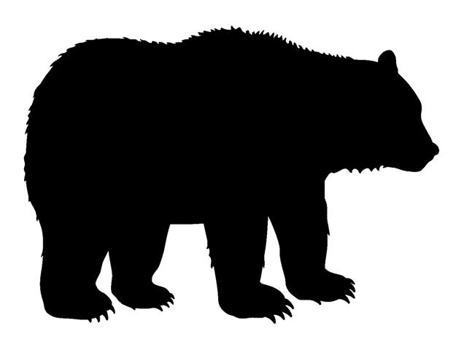](http://www.google.co.uk/url?sa=i&rct=j&q=&esrc=s&frm=1&source=images&cd=&cad=rja&docid=LrHpSsHCzfvKwM&tbnid=GQ4ceEYY0EqSJM:&ved=0CAUQjRw&url=http://www.stickthisgraphics.com/Bear-Silhouette-2-Decal-Sticker-WILD28.htm&ei=kyhHUvfJC4fHtAb9-YDIAw&psig=AFQjCNHGV5ddhq0XQGr2BqN8e33os7LBZw&ust=1380481510021387)