PAWS TO CELEBRATE!

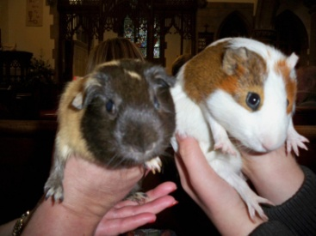

Last Sunday afternoon, a special Pet Service was held at . . . . . Church, . . . . . . As dogs, cats and guinea pigs - with human companions both great and small - all hurried to the pews, the whole Church came alive with wagging tails, miaowing, faint snuffles, and yelps of excitement!

The event, led by . . . . . , was a Service of Thanksgiving and Animal Blessing.

Organiser, . . . . . , said: "There has been great concern that the churches seem to be silent on the subject of animal welfare. These services express the view that cruelty of any kind is incompatible with Christ’s teachings of love, that love is indivisible, and that cruelty towards any sentient creature is a breach of love. Remembered in prayer were those animals suffering commercial and social exploitation."

"Also remembered were those animals who help humankind: As companions, guide dogs, hearing dogs, animals for disabled people, in the detection of crime and at times of war."

