ST FRANCIS TIDE

PET SERVICE

. . . . . CHURCH, . . . . .

SUNDAY 12 OCTOBER 2014 AT 2.00 PM

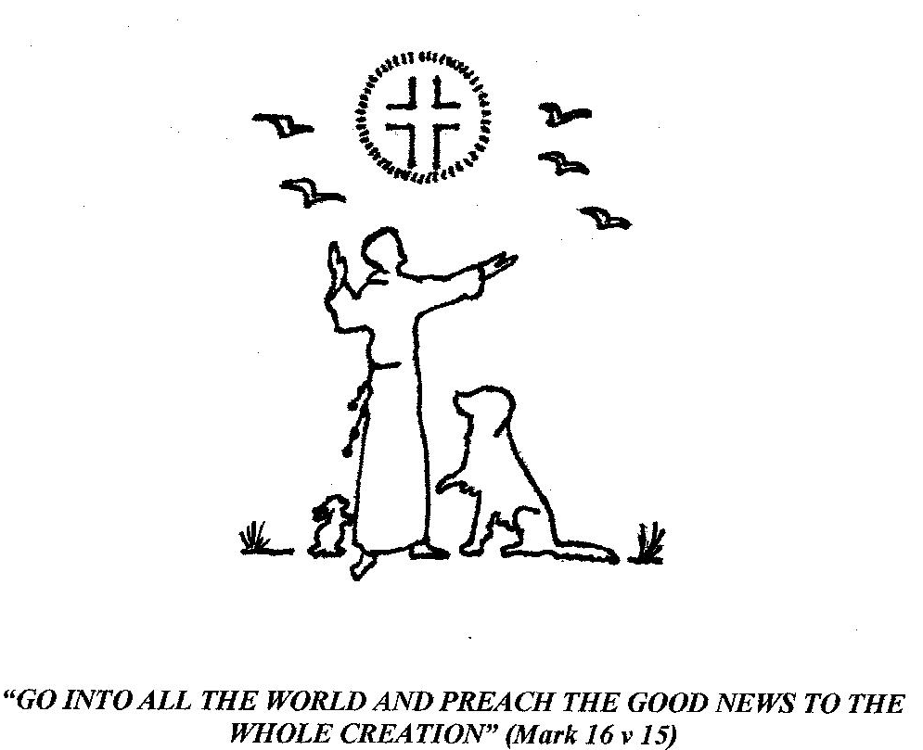

STAND HYMN 7: 'ALL CREATURES OF OUR GOD AND KING'

REMAIN STANDING WELCOME AND BIDDING PRAYER
Almighty God, we come together to thank you for the beauty and glory of your creation; to praise you for your holiness and grace; to acknowledge our responsibility to all animals and for our use of the created world. But first, we ask your forgiveness for the many ways in which animals are abused and exploited, through both ignorance and greed; and we confess before you our part in their suffering, for the times we have remained silent, lacking the courage to speak out in their defence. PAUSE - SILENCE

SIT CONFESSION
Almighty God, You have given us the gracious lordship of your creation with all its beauty. But we have misused our power, turned away from our responsibility and marred your image in us. Forgive us, true Lord, especially for our callousness and cruelty to animals. Help us to follow the way of your Son, Jesus Christ, who showed His power in humility and His lordship in loving service. Enable us, by your Spirit, to walk in newness of life, healing injury, avoiding wrong and making peace with all your creatures. AMEN

ABSOLUTION
God of everlasting love, who is eternally forgiving, pardon and restore us and make us one with you in your new creation. Through Jesus Christ our Lord. AMEN

STAND HYMN 467: 'MORNING HAS BROKEN'

SIT 1ST READING: THOUGHTS ON A COLLECTION OF BIBLE PASSAGES - Genesis 1 v l & 31, Ch 2 v 19-20, Ch 9 v 12-16, Isaiah 11 v 9, John 1 v 1-3 (Presented with the children)

STAND HYMN 189: 'GOD IS WORKING HIS PURPOSE OUT'

SIT 2ND READING: THOUGHTS ON A FURTHER COLLECTION OF BIBLE PASSAGES - Luke 12 v 6, Matt 23 v 37, John 10
v 14-15, Colossians 1 v 19-20, Revelation 5 v 13-14.
SIT SHORT SERMON
SIT: INTERCESSIONS
O God, whose name is Love, you created this world and all that is in it. We ask you to look with compassion and mercy upon us all. Look upon your whole creation, O God, in all its sufferings. Sustain your world and protect your animal creatures from all natural dangers; and from human exploitation, especially in laboratories, factory farms, traps, sport, entertainment, war and pollution. Bless all animals who help and comfort humankind in so many ways: As companions, guide dogs, hearing dogs, helpers for disabled people, and in daily work. We remember all those animals at home, those who are sick, or no longer with us but who remain forever within our love and within your love.
Lord in your mercy: Hear our prayer.

Look upon humankind, O God, your supreme creation, now fallen from your perfect will. Forgive us our selfishness, greed and cruelty and lead us gently back to your way of love. Transform our hearts until they truly reflect the selfless compassion shown to us by your beloved Son, Jesus Christ, whose love was perfect and who loved to the end that He died to give us our salvation. Lord in your mercy: Hear our prayer.

Forgive us our bitterness against those who abuse your creation, for Christ taught us to forgive, even as He forgave. Yet change the hearts of all who use animals with cruelty, so that they may be filled with your love and mercy. Inspire all governments and those in authority to legislate with compassion and justice for the good of all your creation. Lord in your mercy: Hear our prayer.

Guide us all, O God, by your Holy Spirit into your truth and love. Give us the vision to see your whole creation united in worship before your eternal throne. And give us, O God, the penitence to raise Your suffering creatures before you for your healing, justice, mercy and blessing. Merciful Father, accept these prayers for the sake of your Son, our Saviour, Jesus Christ. AMEN

STAND HYMN 449: ‘LOVE DIVINE, ALL LOVES EXCELLING’ (Blaenwern) (During this hymn, a collection will be taken to be shared between . . . . . Animal Sanctuary and . . . . . Church, . . . . . )
SIT: Now, as we seek God's coming Kingdom, we pray together: THE LORD’S PRAYER
Our Father, who art in Heaven, hallowed be thy Name; thy Kingdom come; thy will be done; on earth as it is in Heaven. Give us this day our daily bread. And forgive us our trespasses, as we forgive those who trespass against us. And lead us not into temptation; but deliver us from evil. For thine is the Kingdom, the power and the glory, for ever and ever. AMEN

STAND HYMN 728: ‘WE HAVE A GOSPEL TO PROCLAIM’

BLESSING OF THE ANIMALS
Almighty God, Father, Son and Holy Spirit Bless these animals here and all those for whom we pray. Love them and hold them that at the last they may, together with all creation, praise and exalt you eternally. AMEN

FINAL PRAYER AND BLESSING
Blessed are you, Lord God, for all living creatures you have made. You keep them in your care and not one is lost without your knowing. They glorify you, each in their own way, and speak to us of your beauty and love. May we respect them and cherish them for they are your gift to us: Through them may we come to know you better and praise you, their Creator. This we ask through Christ our Lord. AMEN

May Christ Jesus, who gathers into His love all things in heaven and on earth, give you His Peace.
And the Blessing of God Almighty, the Father, the Son, and the Holy Spirit, be among you and remain with you always.
_______________________

Please take this Service Sheet home with you. Enquiries to . . . . .
For further information on caring for God's creation, please see:- shepherdingcreation.com

“Then I heard every creature in heaven and on earth and under the earth and on the sea, and all that is in them, singing:
‘To Him who sits on the throne and to the Lamb be praise and honour and glory and power, for ever and ever!’” (Revelation 5 v 13)

